# Apply filters to SQL queries

## Project description

SQL provides a powerful and standardized language to interact with databases, enabling you to retrieve, manipulate, define, and analyze data efficiently.

## Retrieve after hours failed login attempts

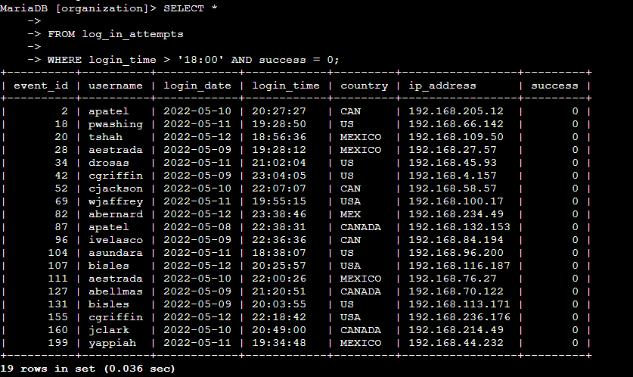

## Retrieve login attempts on specific dates

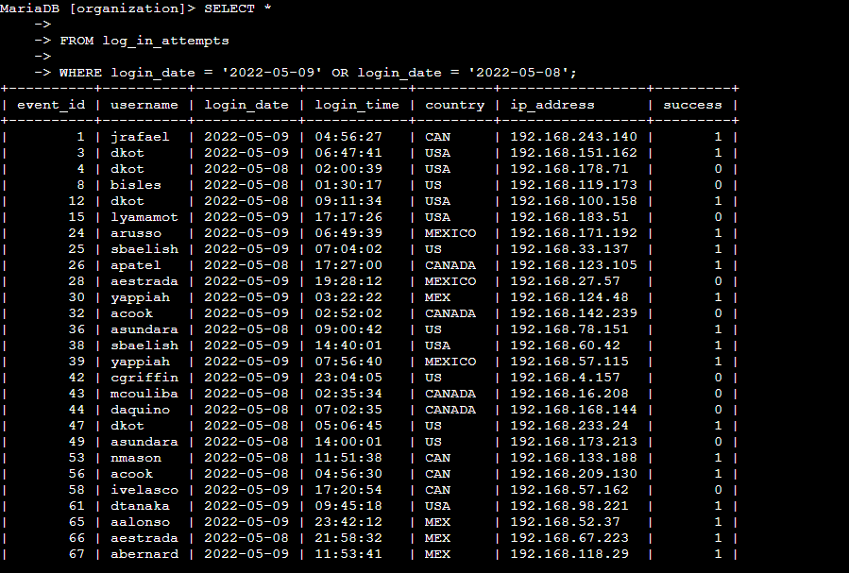

## Retrieve login attempts outside of Mexico

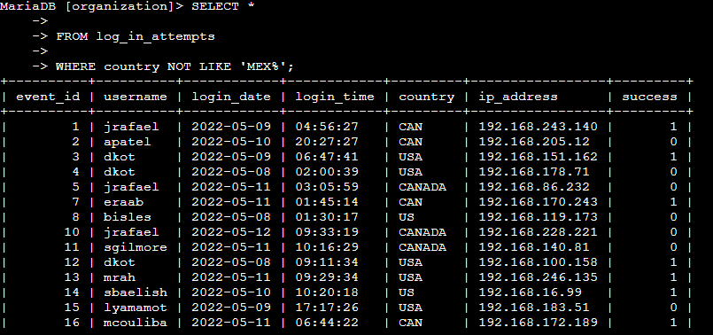

## Retrieve employees in Marketing

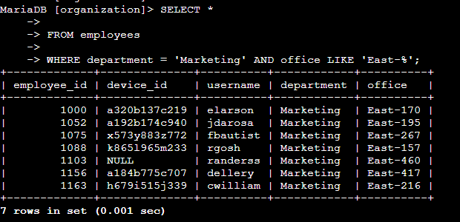

## Retrieve employees in Finance or Sales

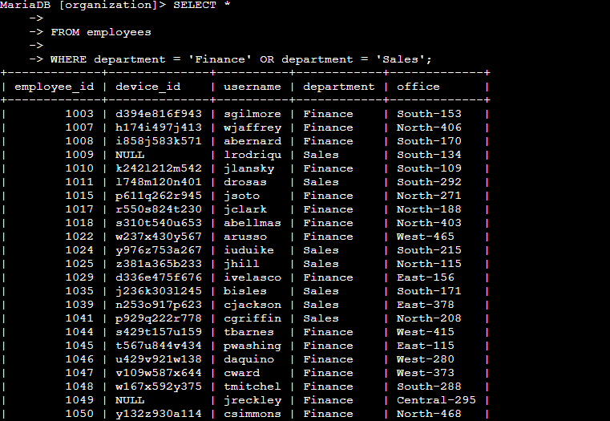

## Retrieve all employees not in IT

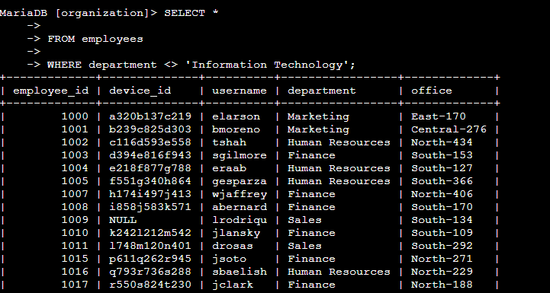

## Summary

In this assignment, there were several tasks related to retrieving and filtering data from a database table called employees. The tasks involved using SQL queries to extract specific information based on different conditions. Here's a summary of the tasks:

Task 1: Retrieve Employees in the Finance and Sales Departments

The goal was to retrieve a list of employees in the Finance and Sales departments, along with their office numbers. The SQL query involved filtering the rows based on the department column to include only the employees from the 'Finance' department.

Task 2: Retrieve Login Attempts After a Certain Date

The task required retrieving data for login attempts made on or after a specified date. The SQL query involved filtering the rows based on the login_date column using the appropriate comparison operator.

Task 3: Retrieve Data Based on Login Attempts and Office Hours

The goal was to investigate failed login attempts that occurred after business hours. The SQL query involved retrieving failed login attempts that happened after a specific time and had a success value of 0 Indicating failure.

Task 4: Retrieve Employees in the Marketing Department in the East Building

The task involved retrieving information about employees in the 'Marketing' department who were located in offices in the East building. The SQL query included filters on the department and office columns to return the needed records.

Task 5: Retrieve Employees in the Finance or Sales Department

The task required retrieving records for employees in the 'Finance' or 'Sales' department. The SQL query involved filtering the rows based on the department column using the appropriate comparison operator.

Task 6: Retrieve Employees Not in the Information Technology Department

The goal was to retrieve records for employees who were not in the 'Information Technology' department. The SQL query included using the NOT operator to filter out employees in the specified department.

Overall, these tasks demonstrated various SQL querying techniques for retrieving specific data from a database table based on specified conditions, allowing for effective data analysis and decision-making.